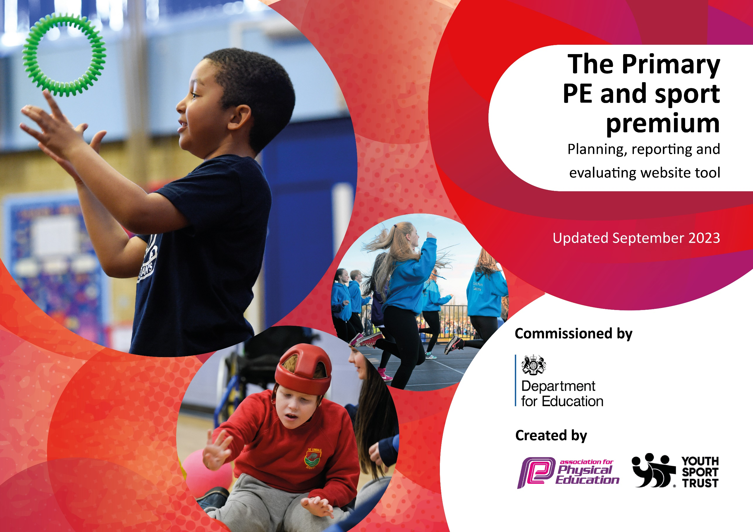

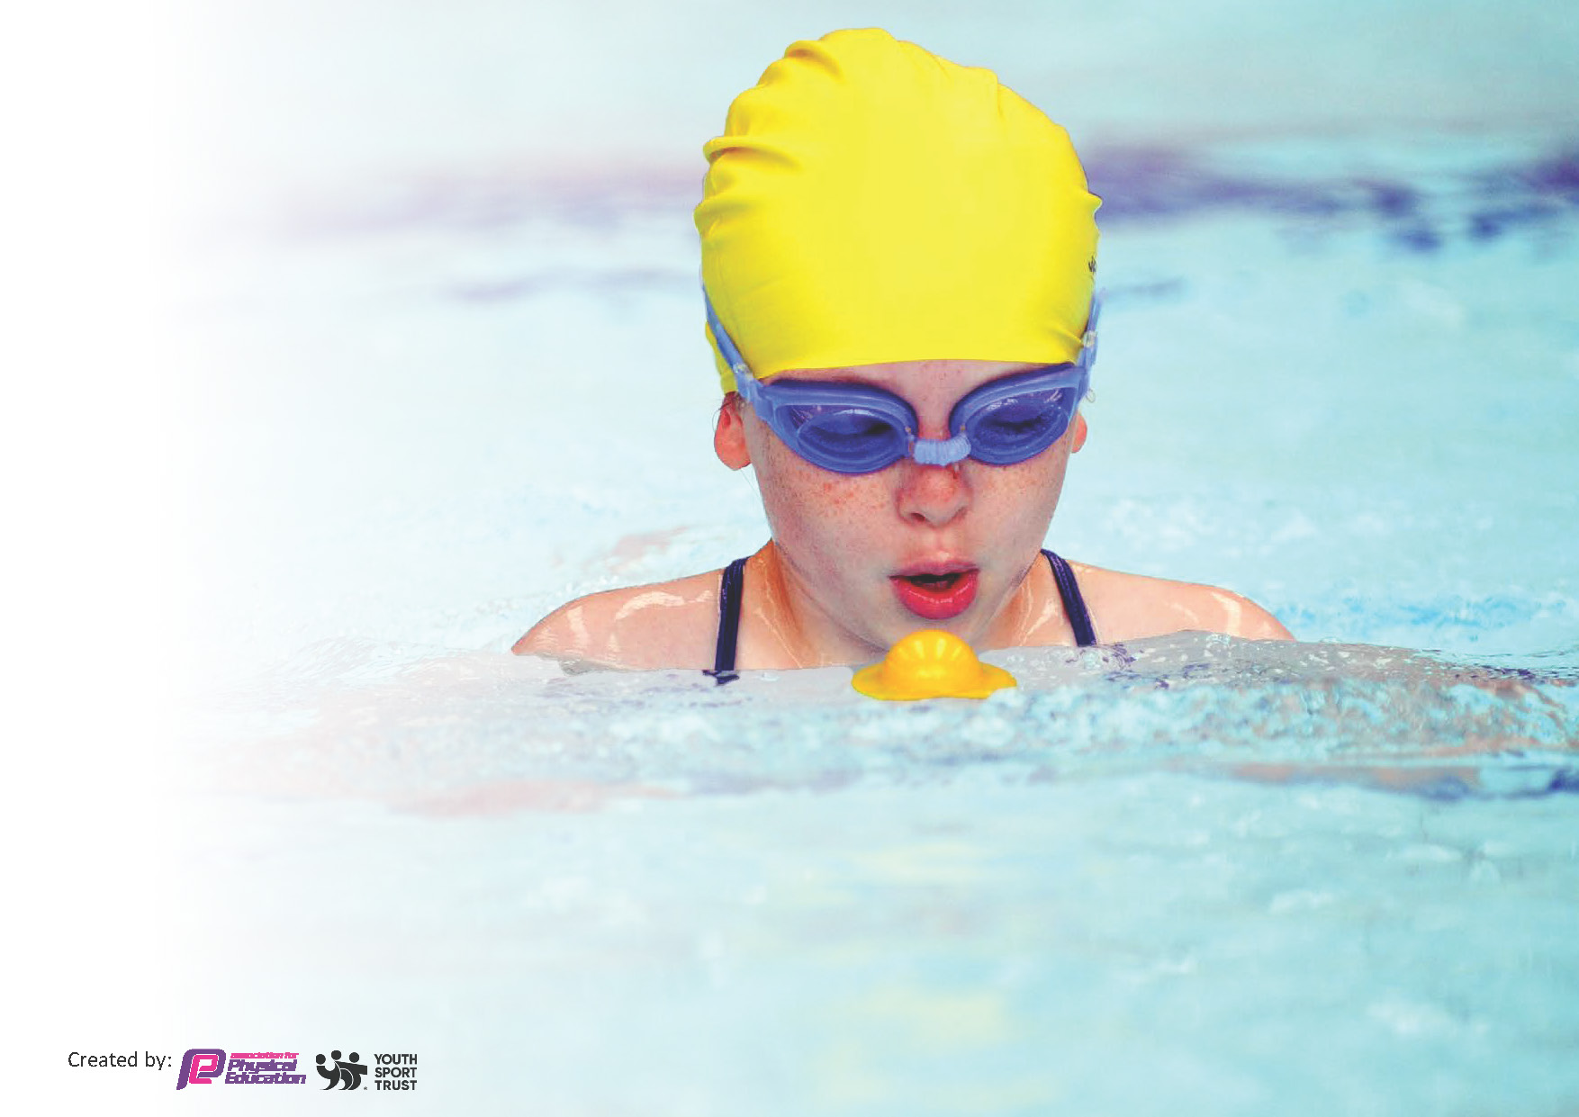
This template can be used for multiple purposes:
by:
- It enables schools to effectively plan their use of the Primary PE and sport premium
- It helps schools to meet the requirements (as set out in guidance) to publish information on their Primary PE and sport premium
- It will be an effective document to support Ofsted inspections enabling schools to evidence progress in Physical Education (PE) and evidence swimming attainment, which forms part of the PE National Curriculum. We would recommend schools consider
the Intent, Implementation and Impact of any spend, as examined within the Education Inspection Framework.

It is important that your grant is used effectively and based on school need.

Schools must use the funding to make additional and sustainable
improvements to the quality of the PE, School Sport and Physical Activity (PESSPA)
they offer. This means that you should use the Primary PE and sport premium to:

- Build capacity and capability within the school to ensure that improvements made now will benefit pupils joining the school in future years
- Develop or add to the PESSPA activities that your school already offers.

The Primary PE and sport premium should not be used to fund capital spend projects; the school’s core budget should fund these. Further detail on capital expenditure can be found in the updated Primary PE and sport premium guidance.

The Primary PE and sport premium guidance, outlines 5 key priorities that funding should be used towards. It is not

necessary that spending has to meet all the key priorities, you should select the priorities that you aim to use any funding towards.

Although completing this template is not a requirement for schools, schools are required to publish details of how they spend this funding. Schools must also outline what the impact this funding has had on pupils’ PE and sport participation and attainment and how any spending will be sustainable in the future. All funding must be spent by 31st July 2024.

The Department for Education has worked closely with the Association for Physical Education (afPE) and the Youth Sport Trust (YST) to develop this template and encourages schools to use it. This template is an effective way of meeting the reporting requirements of the Primary PE and sport premium.
Review of last year’s spend and key achievements (2022/2023)

We recommend you start by reflecting on the impact of current provision and reviewing your previous spend.

Activity/Action | Impact | Comments
Priorities EYFS to build confident physical foundations that will stay with them throughout their school career, by maintain the new EYFS bikes so that the children gain confidence daily on bikes and scooters developing gross motor skills, confidence and spatial awareness.  Provided more opportunities for physical during outdoor play times, by refurbish the main outdoor play area. Creating space to engage children in physical activities. Incudes an active mile playground painting, climbing wall and giant snakes and ladders. | The EYFS staff are confident that the additional bikes are still helping and will continue to for new reception children by improving the physical development aspect of the EYFS curriculum.  More children doing physical movement during play times. Using fine and gross motor skills on the climbing wall. Snakes and ladders game promotes team work, listening and understanding skills. | Continue to keep the bikes maintained for upkeep to be serviced once a year and plan time for more focused bike time.  Keep promoting the active mile and create and active mile competition between classes for afternoon break time.

Key priorities and Planning
This planning template will allow schools to accurately plan their spending.

Action – what are you planning to do | Who does this action impact? | Key indicator to meet | Impacts and how sustainability will be achieved? | Cost linked to the action
To achieve a higher percentage of children accessing the school competitions for organised active games and sports by introduce lunchtime sport sessions/activities for pupils and for whole school participation during playtimes, dinner time and after school clubs, as well as to provided more opportunities for physical during outdoor play times.  To have correct equipment to support all areas of PE curriculum.  To achieve high quality PE lessons and a curriculum timetable that meets the sports teachers time requirements. | Teaching staff on lunchtime duty, coaches - as they need to lead the activity pupils – as they will take part.  Play leaders to lead first half lunchtime activities.  Outside coach to be paid to run after school PE sessions linked to upcoming after school competitions for every year group, throughout the year making sure the activities appeal to a wide range of children.  PE staff to have equipment to carry out all areas of PE and introduce and engage children into different sports to give a wide range of PE experience.  PE coordinator to teach Class 2, highly qualified TA to teach in Class 3 and 4 PE lessons to ensure high quality PE lessons, using core tasks to assess and progress children’s learning. | - Key indicator 1: The engagement of all pupils in regular physical activity – Chief Medical Officers guidelines recommend that primary school pupils undertake at least 30 minutes of physical activity a day in school.  - Key indicator 2: The engagement of all pupils in regular physical activity – the Chief Medical Officer guidelines recommend that all children and young people aged 5 to 18 engage in at least 60 minutes of physical activity per day, of which 30 minutes should be in school.  - Key indicator 4: Broader experience of a range of sports and activities offered to all pupils.  - Key indicator 2: The profile of PESSPA being raised across the school as a tool for whole school improvement.  - Key indicator 4: Broader experience of a range of sports and activities offered to all pupils. | More pupils meeting their daily physical activity goal, more pupils encouraged to take part in PE and Sport Activities.  More children doing physical movement during play times. Using fine and gross motor skills on the climbing wall. Snakes and ladders game promotes team work, listening and understanding skills.  To replenish the PE equipment ensuing the children have the correct equipment to participate successfully in a progressive curriculum.  Year 3, 4, 5 and 6 maintain two hours of PE a week. The Time table to continue to have each year in KS2 with 2 hour PE time slot. All KS2 classes to have two hours of PE weekly to increase coverage of all areas of PE and more in depth knowledge of PE skills. | Play leader training part of BSSP funding. £6000 BSSP payment.  Whole school undertake an Olympian activity day and raised money to fund equipment.  Included in wage payment.

To refresh PE skills and knowledge of teachers for good practice. CPD for teachers.  Enrich the curriculum with a wider choice of sports that are not generally offered at school. | Primary generalist teachers.  PLT meeting and Existing/ Refresher subject Leadership CPD for AB.  Coach to support in PE lesson. To help upskill teacher and develop techniques and strategies to help support during PE lesson with behaviour management/ warm up and cool down activities/ teaching sport skills.  Coach to be brought in for afternoon skills support and afterschool clubs.  Aim educations to come in to coach education enrichment, sports, fitness and well-being within all classrooms. | - Key Indicator 1: Increased confidence, knowledge, and skills of all staff in teaching PE and sport.  - Key indicator 3: Increased confidence, knowledge and skills of all staff in teaching PE and sport.  - Key indicator 5: Increased participation in competitive sport.  - Key indicator 1: The engagement of all pupils in regular physical activity – Chief Medical Officers guidelines recommend that primary school pupils undertake at least 30 minutes of physical activity a day in school.  - Key indicator 4: Broader experience of a range of sports and activities offered to all pupils.  - Key indicator 5: Increased participation in competitive sport. | Primary teachers more confident to deliver effective PE supporting pupils to undertake extra activities inside and outside of school, as a result improved pupil’s attainment in PE. Skills 2 play coach to support CPD and upskill in EYFS.  Multi-skills and Rugby coach to support CPD and upskill in Year 1 and 2.  Gymnastics and Netball coach to support CPD and upskill in Year 3 and 4.  Football and Handball coach to support CPD and upskill in Year 5 & 6.  Coach to provide afterschool clubs linked to upcoming competitions and link to areas of upskilling for PE.  Providing children with enrichment and experiences that could contribute to future physical hobbies.  As part of the PE session and after school clubs, the children in KS2 that met the PE and school values got invited to the Jacksonville Jaguars Jag Tag. | CPD training part of BSSP funding.  £4500 after school coaches Ed start.  £4029 Aim education enrichment sessions.

Key achievements 2023-2024
This template will be completed at the end of the academic year and will showcase the key achievements schools have made with their Primary PE and sport premium spending.

Activity/Action | Impact | Comments
Enrich the curriculum with a wider choice of sports as well as to increase the involvement and participation of SEND children through the use of AIM education, active 60 competitions and afterschool sports clubs.  Each class has a session a week for a group of children to get support with emotional and physical development. Giving children the chance to get out of a classroom setting and be able to improve understanding and development of emotions as well as keeping active and knowing the benefits of being active.  At least one active 60 competition for each KS2 class to help children all feel included and learn about help competition and self-motivation.  After school clubs with a wide range of activities so all children can find a sporting activity they enjoy. | All children with neurodiverse needs to have access to sport and sessions to help with their development.  All children to be included with school competitions.  A wider knowledge of the importance of keeping active and emotional development and understanding. | All children on the SEND register have taken part in AIM sessions. All children on the SEND register have either been involved in afterschool club, active 60 competition or other competitions.  All children were involved in sports day.

Swimming Data
Meeting National Curriculum requirements for swimming and water safety.
Priority should always be given to ensuring that pupils can perform safe self-rescue even if they do not fully meet the first two requirements of the National Curriculum programme of study

Question | Stats: | Further context  Relative to local challenges
What percentage of your current Year 6 cohort can swim competently, confidently and proficiently over a distance of at least 25 meters? | 67% | Our children go swimming for three half terms in year 3 and three half terms in year 4.
What percentage of your current Year 6 cohort can use a range of strokes effectively [for example, front crawl, backstroke, and breaststroke]? | 76% | Even though our pupils swim in year 3 and 4, we are reporting on their attainment on leaving primary school at the end of the summer term 2024.

What percentage of your current Year 6 cohort are able to perform safe self-rescue in different water-based situations? | 12%
If your schools swimming data is below national expectation, you can choose to use the Primary PE and sport premium to provide additional top-up sessions for those pupils that did not meet National Curriculum  requirements after the completion of core lessons. Have you done this? | No
Have you provided CPD to improve the knowledge and confidence of staff to be able to teach swimming and water safety? | No

Signed off by:

Head Teacher: | A Leyland Head Teacher
Subject Leader or the individual responsible for the Primary PE and sport premium: | Alexandra Bradley Class teacher and PE subject lead
Governor: | (Name and Role)
Date: | 26.07.2024

